Jenkins auto build on commit – set webhook

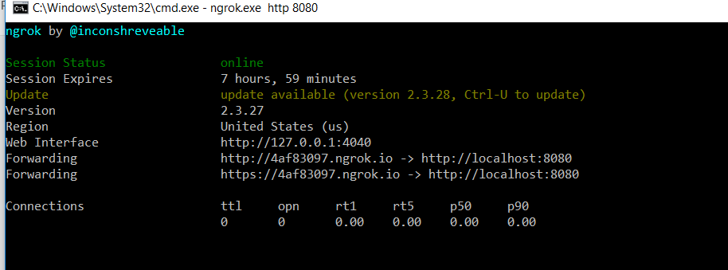

http://4af83097.ngrok.io -> http://localhost:8080

https://4af83097.ngrok.io -> <http://localhost:8080>

